Bangladesh Medical Association (BMA)
List of Life Member-14
54. BMA Rajbari Branch

Sl No | Voter No | Voter Details
1 | Voter No  LM-5400001  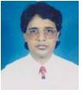 | DR. A. F. M. SHAFI UDDIN  F/Name: Late Belayet Hossain  M/Name:  BM & DC Reg. No:  NID:  Cell:  Address: Thana Health Complex,  Pangahsia,  Rajbari.  Blood Group:  E X P I R E D
2 | Voter No  LM-5400002  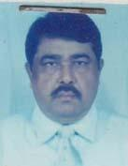 | DR. MD. SYEDUR RAHMAN  F/Name: Late. Ismail Hossain Biswas  M/Name: Late. Momena Khatun Pakhi  BM & DC Reg. No: 9367  NID:  Cell: 01711287432  Address: UH & FPO, Upazilla Health Complex, Pangsha, Dist: Rajbari  Blood Group: B+
3 | Voter No  LM-5400003  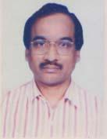 | DR. MD. NURUL AMIN  F/Name: Md. Abdul Majid Khan  M/Name: Late. Nurunnahar Begum  BM & DC Reg. No: 14591  NID: 8227606122918  Cell: 01711407040  Address: Civil Surgeon Officer, Rajbari  Blood Group: A+
4 | Voter No  LM-5400004 | DR. MD. ABDULLAH-AL-SAYEEF  F/Name: Md. Abu Sayeed  M/Name: Mrs. Rozeena Sayeed  BM & DC Reg. No: 51130  NID: 2695435974842  Cell: 01730160116  Address: UHC, Baliakandi, Rajbari  Blood Group: A+
5 | Voter No  LM-5400005  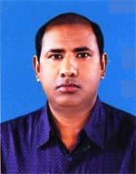 | DR. SHEIKH MOHAMMAD ABDUL HANNAN  F/Name: Md. Akbar Ali Sheikh  M/Name: Mrs. Amena Khatun  BM & DC Reg. No: 29381  NID:  Cell: 01712025320  Address: Sazzan Kanda, Sadar, Rajbari  Blood Group: B+
6 | Voter No  LM-5400006  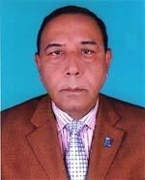 | DR. PARIJAT KUMAR PAUL  F/Name: Panchanan Paul  M/Name: Protima Rani Paul  BM & DC Reg. No: 7785  NID: 19539196213247343  Cell: 01715024987  Address: Rajbari Clinic, Rajbari  Blood Group: O+
7 | Voter No  LM-5400007  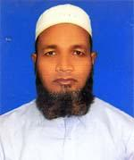 | DR. MD. ABDUL QUDDUS  F/Name: Late Md. Monir Uddin Mollah  M/Name: Rahima Begum  BM & DC Reg. No: 18992  NID:  Cell: 01711579263  Address: 1 No. Beradanga, Hospital Road, Rajbari  Blood Group: A+
8 | Voter No  LM-5400008 | DR. MD. ABDUR RASHID  F/Name: Md. Abed Ali Khan  M/Name: Most. Rebeka Khatun  BM & DC Reg. No: 25251  NID: 8227607126291  Cell: 01711193329  Address: 31, Kazi Kanda, Post+Dist-Rajbari  Blood Group: B+
9 | Voter No  LM-5400009 | DR. MD. NAZMUL HUDA  F/Name: Md. Moslem Uddin  M/Name: Mrs. Monowara Begum  BM & DC Reg. No: 58057  NID: 8227304450675  Cell: 01733431204  Address: Vill-Narayon Pur, Post+P.s-Pangsha, Dist-Rajbari  Blood Group: AB+
10 | Voter No  LM-5400010 | DR. MD. AKRAMUL KARIM  F/Name: Md. Fazlul Karim Khan  M/Name: Mrs. Rezia Begum  BM & DC Reg. No: 37951  NID: 1923107414237  Cell: 01733054282  Address: Rabeya Private Hospital, Rajbari  Blood Group: O+
11 | Voter No  LM-5400011 | DR. MD. RAHIM BAKSH  F/Name: Late Md. Elahi Baksh  M/Name: Mrs. Zomela Begum  BM & DC Reg. No: 18553  NID: 8227609138808  Cell: 01711987585  Address: Doctor\'s Quarter , 2nd Floor, Sadar Hospital, Rajbari  Blood Group: B+
12 | Voter No  LM-5400012  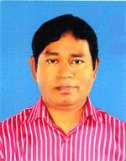 | DR. DIPAK KUMAR BISWAS  F/Name: Narayan Chandra Biswas  M/Name: Charu Bala Biswas  BM & DC Reg. No: 22169  NID: 82276061122733  Cell: 01712073298  Address: UH & FPO Kalu Khali, Rajbari  Blood Group: O+
13 | Voter No  LM-5400013 | DR. K. M. ABU JALAL  F/Name: Late K. M. Rostum Ali  M/Name: Fatema Khatun  BM & DC Reg. No: 37510  NID:  Cell: 01712530789  Address: Vill-Gouraangopur, Post-Kagzana 7722, P.s-Pangsha, Rajbari  Blood Group: B+
14 | Voter No  LM-5400014  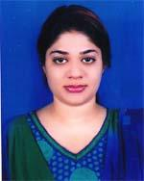 | DR. MIZNA MOSTOFA  F/Name: Dr. Md. Golam Mostofa  M/Name: Kazi Habiba Khatun  BM & DC Reg. No: 78294  NID: 2627205030116  Cell: 01722995453  Address: Road No.-1, Beradanga, House No.-129, Post+Dist-Rajbari  Blood Group: O+

